Report of LSTM Project

# Acknowledgement

I would like to thank professor Dr. Piyush Kumar and TA Soheila Abrishami for giving me the opportunity for participating this project, and Soheila also gave me a lot of good advices during the project. At the beginning of this semester, I almost know nothing about machine learning, not to say RNN or LSTM. Now I could use Keras and Tensorflow to construct simple model and make forecast for time series data, all the credit should go to your help.

# Introduction

Most of my code was based on: <https://machinelearningmastery.com/multi-step-time-series-forecasting-long-short-term-memory-networks-python/> , and I made changes every week to the code, to achieve my short-term targets.

From the hidden layers’ point of view, during the first four weeks, I only used one lstm hidden layer plus one output layer. I began to use two hidden layers’ model from the 5th week.

From the validation’s point of view, during the first 3 weeks, I used the testing data set to twist the hyper-parameter of the model, and this method would introduce information leaking from testing data to the model. From the 4th week, I began to use chosen validation data to twist the hyper-parameters of the model.

From the data integrity’s point of view, during the first 6weeks, I kept the original data intact. During week 7, I did some repairment to the original data, and this repairment did introduced a better result.

Detailed report of each week could be found in my repository.

# One LSTM Hidden Layer, many to one (week 1)

For the first 3 weeks, the following method was used to twist the model’s hyper-parameters (number of neurons, epochs):



During week 1, I only forecast one day’s data once, the result data is like the following:



# One LSTM Hidden Layer, many to many (week 2-3)

During week 2 and week 3, I forecasted 7 day’s data once, under the following format:



The testing data set (to be forecasted) is shown as following:



Using this method, the first 10 7-day’s forecasts is shown as following (real data shown in blue color):



# One LSTM Hidden Layer, using validation data (week 4)

From week 4, I used the validation data to adjust the hyper-parameters:



Because out data is temporal data, whose sequence can’t be inversed, so k-fold cross validation is not suitable, and simple hold-out validation would be too simple. After preparing, we have 487 samples for train (from index 0 to index 486), we will further divide these samples into train data and validation data cyclically, as follows (we show 10 validation sets):



But this still could have problems, because each train data set and validation data set overlapped for 6 days, and this could introduce information leaking from validation data into the model, and thus introduce unexpected better performance for validation.

In week 7, I corrected the method by making the interval among each validation data to be 28 days instead of 22 days.

# Two Hidden Layers: LSTM + Dense (week 5)

After make hundreds of try, I adopted the hidden neurons number of 12 and 4, the training epochs to be 200. The first 8 7-day’s forecasts:

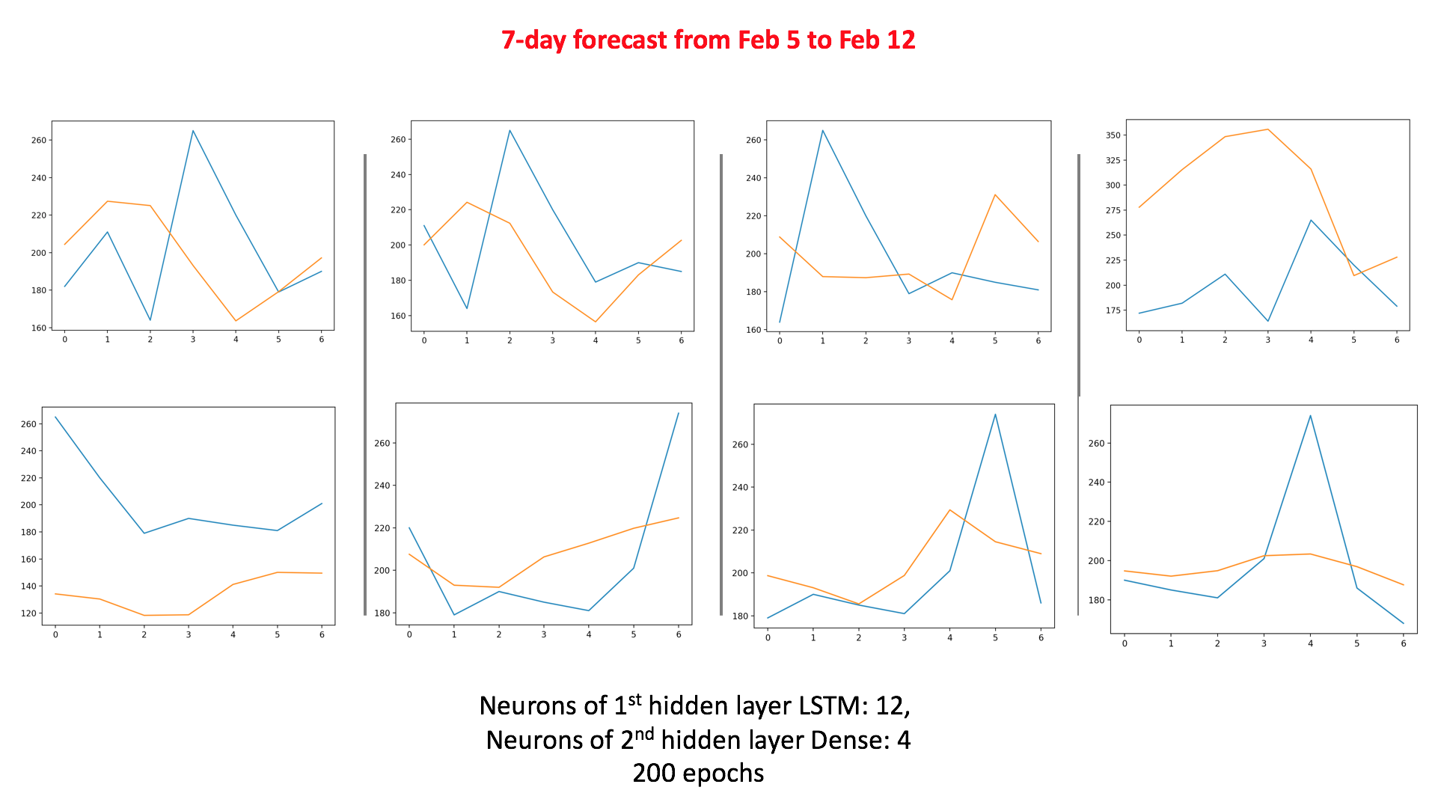

# Two Hidden Layers: LSTM + LSTM (week 6)

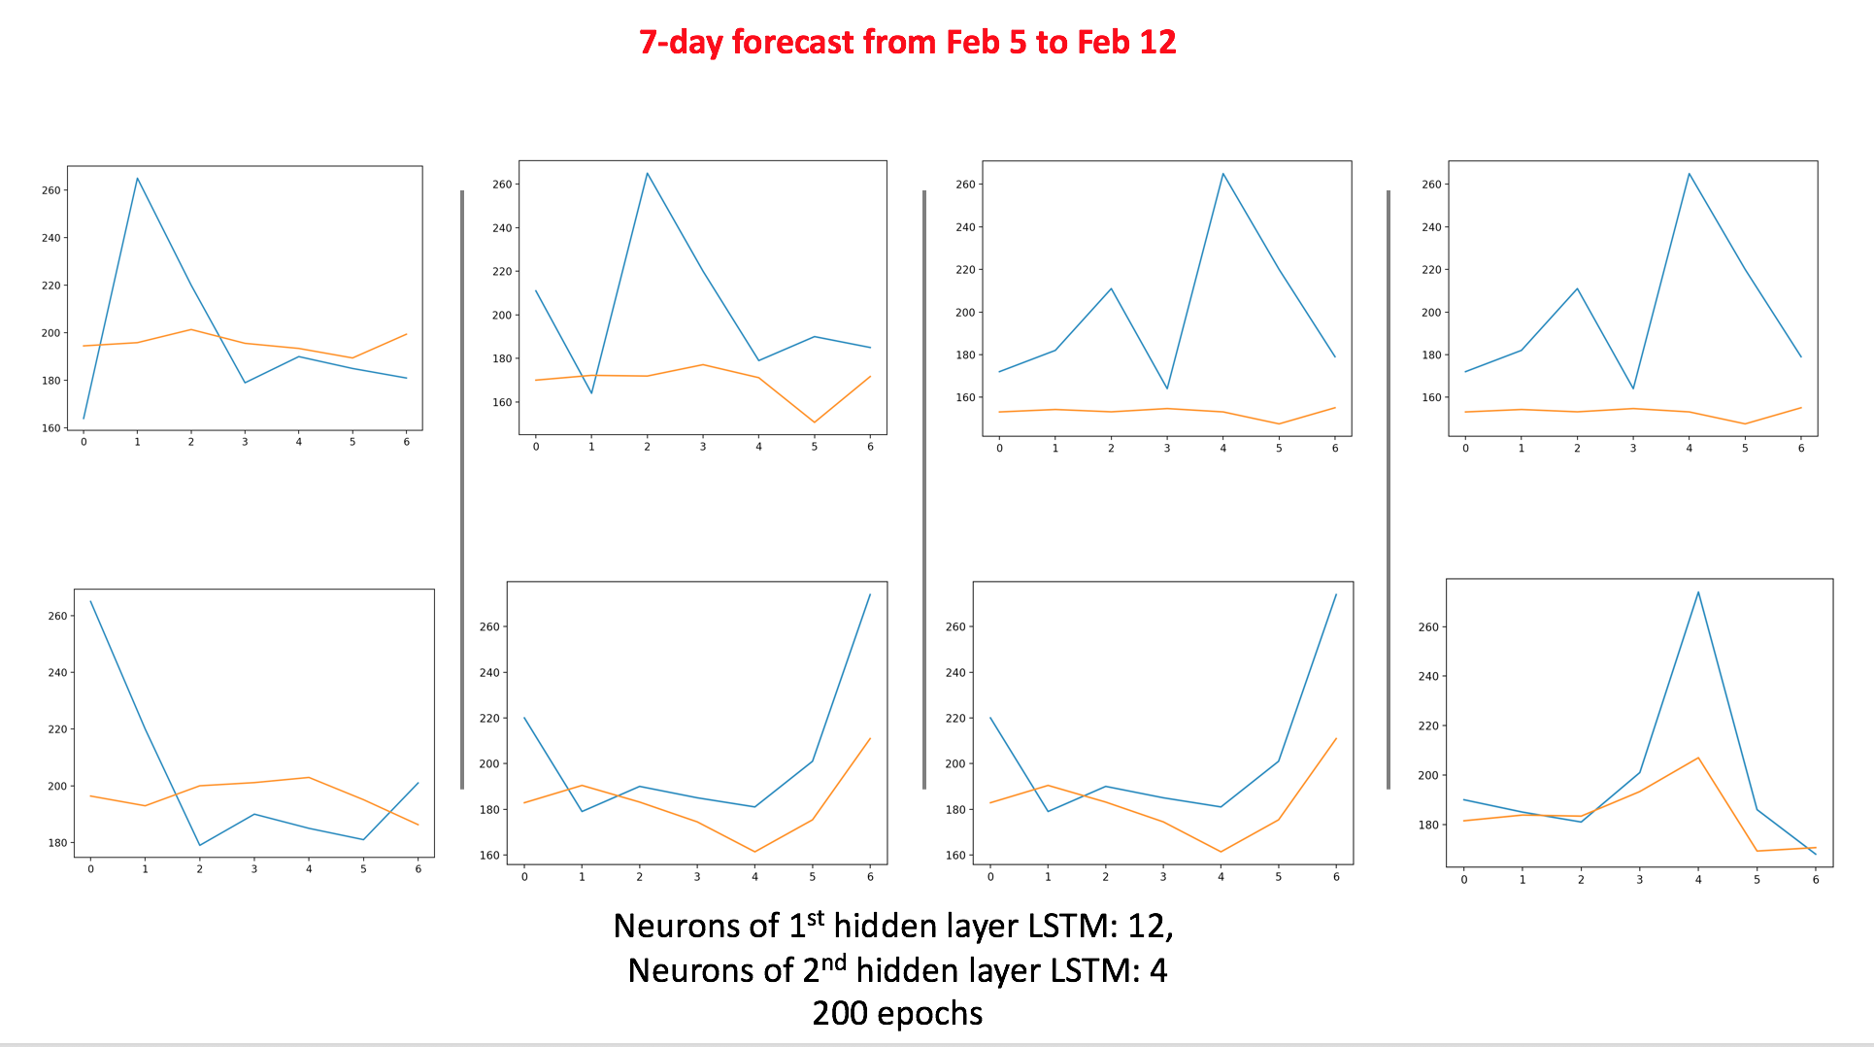

# Repair data, LSTM + LSTM (week 7)

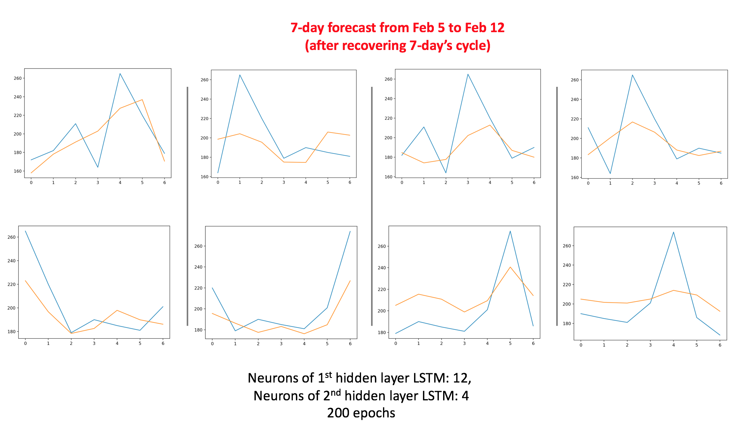

The final RMSE data (30 turns’ average):



The final MAPE data:

